DreamOracle: AI Based Dream Interpreter

Tanvi Gunjal

Department of Computer Engineering

Vishwakarma Institute of Technology

Pune, India

tanvi.gunjal22@vit.edu

***Abstract*— Dream interpretation has long fascinated both psychologists and individuals seeking self-awareness. With advancement in AI (Artificial Intelligence) and support of Natural Language Processing (NLP), the potential to automate the interpretation of dreams has become a promising area of exploration. This paper presents DreamOracle, an AI-powered web application built using MERN (MongoDB, Express.js, React.js, Node.js) stack, designed to offer users symbolic interpretations of their dreams. The system accepts free-form text descriptions of dreams and uplevel AI-based language models to generate meaningful, human understandable interpretations rooted in psychological and cultural symbolism. Along with this, DreamOracle also provides an interactive, user-friendly platform. The project demonstrates how AI can complement human curiosity by delivering personalized insights in real-time, creating new opportunities in the intersection of technology and human consciousness.**

***Keywords—Artificial Intelligence (AI), DreamOracle, Interpretations, Natural Language Processing (NLP), MERN Stack***

# Introduction

Dreams have intrigued human beings for centuries, serving as windows into the subconscious and often offering insight into personal thoughts, emotions, and hidden desires. Psychologists, neurologists, and cultural researchers have long attempted to decode the symbolism behind dreams to understand their relevance in mental health and daily life. Traditional dream interpretation is largely subjective and requires a combination of experience, intuition, and psychological understanding, making it inaccessible to many individuals in need of personal insight.

With the rapid advancement of artificial intelligence (AI) and natural language processing (NLP), it has become feasible to replicate certain aspects of human reasoning and symbolic analysis through computational methods. AI-powered systems can now interpret and generate human-like text, creating new opportunities to automate and enhance tasks that previously required human expertise.

This paper introduces DreamOracle, an AI-powered web application designed to provide users with symbolic interpretations of their dreams. The application leverages the widely adopted MERN stack — MongoDB, Express.js, React.js, and Node.js — as its technological foundation. The core of DreamOracle focuses on transforming user-inputted dream descriptions into meaningful, context-aware interpretations generated by an AI language model. This approach aims to narrow the void between modern artificial intelligence capabilities and the age-old practice of dream interpretation.

DreamOracle's intuitive design, combined with AI-generated insights, allows users to explore the meanings of their dreams in a convenient and interactive manner. The platform demonstrates the potential of merging psychological curiosity with AI technologies, offering a new perspective on self-reflection and emotional discovery.

# Literature Review

Dream interpretation has long been a subject of interest, with foundational theories proposed by Freud [1] and later expanded upon by Griffin's expectation fulfillment theory [2]. These theories underscore the significance of dreams in understanding human cognition and emotion.

Recent advancements in natural language processing (NLP) have opened new avenues for analyzing dream narratives. Bertolini et al. [3] demonstrated that large language models (LLMs) could effectively analyze dream reports, revealing that such reports are more predictable than previously assumed. Similarly, Panchagnula et al. introduced DreamNet, a multimodal framework that decodes semantic themes and emotional states from textual dream reports, achieving high accuracy in both text-only and EEG-enhanced modes [4].

Initial efforts to employ Hugging Face models, such as Vamsi_T5 [5] and ramsrigouthamg/t5_paraphraser [6], for paraphrasing dream narratives were explored. However, these models, primarily trained on datasets like PAWS, were not tailored for the nuanced and metaphorical nature of dream content, leading to suboptimal results. Consequently, the OpenAI API was adopted, offering more coherent and contextually relevant interpretations due to its extensive training on diverse datasets.

Further studies have explored the cultural aspects of dream interpretation. Varol and Menczer [7] analyzed dream networks across cultures, highlighting both universal and culture-specific symbols. The cognitive neuroscience perspective, as discussed by Schwartz and Maquet [8], emphasizes the challenges in studying dreams due to their subjective nature and reliance on verbal reports.

In the realm of goal setting, Maynard et al. [9] compared symbolic inverse planning with deep learning approaches for goal recognition, finding that deep learning methods achieved better accuracy. This aligns with the objectives of Dream Oracle, which aims to transform dream narratives into actionable goals using advanced NLP techniques.

Additional research has delved into the semantic analysis of dream content. Studies by Foulkes [10] and Domhoff [11] have provided insights into the structure and content of dreams, while advancements in computational linguistics have facilitated more objective interpretations [12].

The integration of AI in dream analysis is further supported by works focusing on the emotional aspects of dreams. For instance, studies have shown correlations between specific dream themes and emotional states, such as anxiety associated with falling dreams [13].

Moreover, the application of NLP in therapeutic contexts has been explored. Research indicates that AI-driven analysis of dream content can aid in mental health diagnostics and personalized therapy [14]. This underscores the potential of platforms like Dream Oracle in contributing to psychological well-being.

Lastly, the challenges in dream research, including methodological issues and the influence of laboratory environments on dream content, have been documented [15]. These considerations are crucial in designing systems that aim to interpret dreams authentically and effectively.

# Methodology

#### *Technical Details*

The DreamOracle application is built using a modular and scalable web architecture design to ensure flexibility, maintainability, and seamless integration. The system leverages the widely used **MERN** stack, which stands for;

(M) MongoDB, (E) Express.js, (R) React.js, (N) Node.js. This stack was chosen because of its strong community support, ease of deployment, and compatibility with modern web standards.

The complete technology stack is organized as follow:

* **Frontend:**
  + **React.js**: For building interactive user interfaces and managing application state.
  + **Axios**: For making asynchronous API calls to the backend.
  + **CSS Modules**: For scoped styling.
* **Backend:**
  + **Node.js**: Runtime environment for executing JavaScript server-side.
  + **Express.js**: For handling REST API routing and middleware operations.
  + **OpenAI API**: used for interpreting dreams via prompt-based language modeling
* **Database**:
  + **MongoDB (Atlas)**: Document based NoSQL database for storing user profiles, dreams and interpretation history.
* **Authentication**:
  + **Clerk**: Used for user sign-up, login, session management, and securing data routes.
* **CORS (Cross-Origin Resource Sharing):**
  + **CORS** is configured on the backend to allow secure communication between the React frontend and Express backend hosted on different origins.
  + This mechanism ensures that HTTP requests such as POST and GET are allowed only from trusted sources, thereby enhancing security during data exchange.
* **Version Control & Deployment:**
  + **Git and GitHub**: For source control, collaboration, and change tracking.
  + **Vercel**: For deploying the service with auto-scalable infrastructure.
  + **Render**: For deploying the server services.

#### *Proposed Model*

Unlike prior research in dream interpretation that focused primarily on experimental, psychology-centered studies or multimodal data collection such as EEG-enhanced frameworks, the DreamOracle system is designed as a lightweight, deployable AI-powered web application aimed at the direct interpretation of user-submitted dream narratives through natural language. Rather than attempting to model the cognitive or emotional underpinnings of dreams from a scientific perspective, DreamOracle takes a user-centric approach, treating each dream as a symbolic statement that can be restructured into an interpretation for personal reflection and goal orientation.

While prior literature such as DreamNet [4] has demonstrated how multimodal architectures can detect semantic themes in dreams by incorporating EEG signals, the DreamOracle model is focused exclusively on text-based, real-world inputs from users without reliance on clinical or laboratory data. This shift ensures the model’s accessibility and practical application for non-expert audiences.

Similarly, where studies have employed paraphrasing-based NLP models like Vamsi_T5 and ramsrigouthamg/t5_paraphraser [5][6] for transforming dream narratives, DreamOracle’s development process deliberately moved away from these tools due to their limitations in interpreting metaphorical and symbolic content. Such models were found to be overly literal, lacking the depth required for dream interpretation beyond surface-level rephrasing. Instead, the project integrates OpenAI’s GPT-based API, which through prompt engineering, allows the generation of interpretations that are not only linguistically coherent but also symbolically enriched — aligning more closely with the cultural and psychological dimensions of dream interpretation as discussed by Varol and Menczer [7].

The DreamOracle system further differentiates itself from theoretical frameworks like Griffin’s expectation fulfillment theory [2] by focusing less on dream function within cognitive science and more on their transformation into actionable self-reflective narratives. The model acts as an assistive tool rather than an analytical engine, using AI to offer potential symbolic meanings while leaving the emotional interpretation to the discretion of the user.

In essence, DreamOracle stands at the intersection of practical AI deployment and human-centric design. Its layered architecture — comprising user input collection, AI-based symbolic interpretation, MongoDB-based data storage, and personalized visualization — creates a cycle that encourages long-term self-reflection rather than one-time analysis. This distinction makes DreamOracle not only an academic exploration of dream interpretation but also a functional tool for personal development.

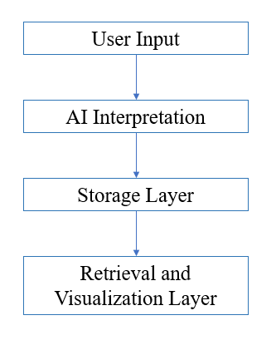

Fig. 1: Proposed Model Architecture

#### *System Integration and Architecture*

The DreamOracle platform is designed as a cohesive system where multiple technologies — spanning frontend, backend, cloud infrastructure, and AI services — are tightly integrated to ensure a smooth and consistent user experience. The goal of this integration is to provide an environment where users can securely submit dream narratives, receive AI-generated interpretations, and maintain an organized personal record of their symbolic insights. From data submission to interpretation delivery and storage, every component is synchronized to maintain efficiency, scalability, and ease of use.

The system integration workflow is structured as follows:

1. **User Authentication;**

New or existing users authenticate securely using Clerk, an authentication service that handles registration, login, session control, and token issuance for secured API access.

1. **Dream Submission;**

Once authenticated, users submit their dream descriptions through the frontend interface, which are then transmitted to the backend server via secure RESTful API calls.

1. **AI-based Processing;**

The backend leverages prompt engineering techniques to format the submitted input and forwards it to the OpenAI API for interpretation. The AI model generates a symbolic and context-aware interpretation that is both human-readable and psychologically meaningful.

1. **Data Storage and Management;**

The original dream input along with the generated interpretation and metadata (user ID, timestamp) are stored in MongoDB Atlas, providing a flexible and scalable document-based storage solution.

1. **User Dashboard Interaction;**

Users can access a personal dashboard that displays their historical dream interpretations, helping them track recurring themes and reflections over time.

1. **Deployment and Scalability;**

The frontend application is deployed using Vercel, a cloud platform that offers serverless deployment, continuous integration, and automatic scalability. The backend is hosted on Render platform, cloud services capable of scaling based on user demand, ensuring reliable performance even under load.

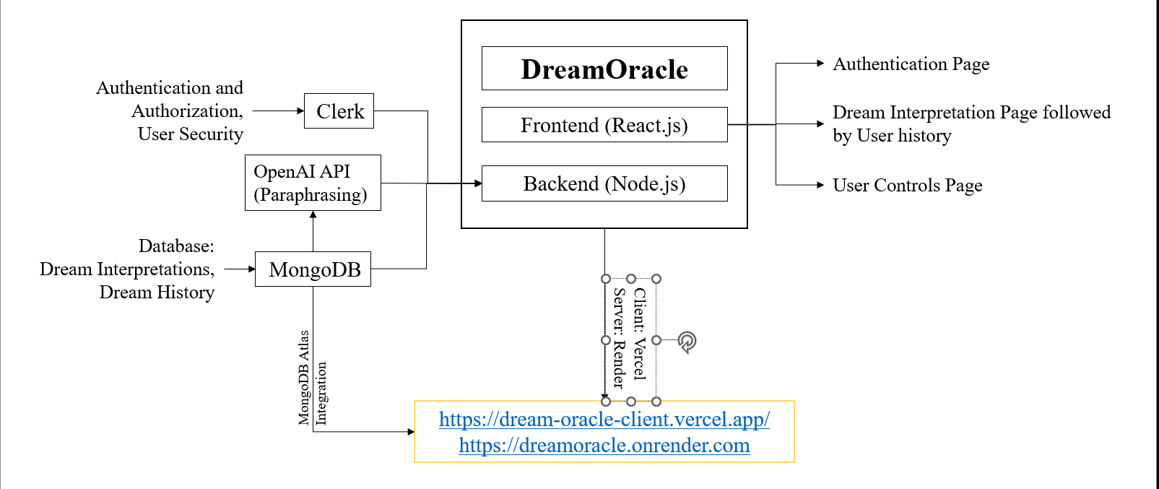

Fig. 2: System Architecture

# Results

The DreamOracle platform was evaluated through iterative frontend testing, backend validation, and user interaction scenarios. The system’s performance was assessed based on its ability to interpret user-submitted dream descriptions into coherent symbolic meanings and store them reliably for long-term tracking. Visual validation was performed using the following elements:

The React.js-based frontend was tested for its ability to accept, transmit, and display dream interpretations in a user-friendly and intuitive manner.

MongoDB Atlas was used to verify proper storage and retrieval of dream logs, including metadata such as timestamps and user identifiers.

Clerk’s authentication and user management dashboard was employed to validate secure login, session control, and multi-user identity separation.

The following figures illustrate the functional components of DreamOracle:

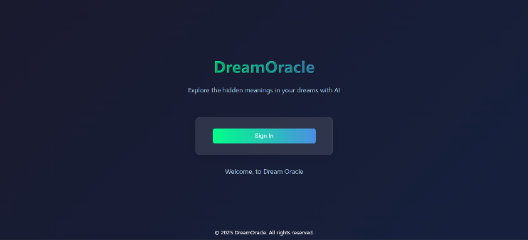

Fig. 3: Introduction Page

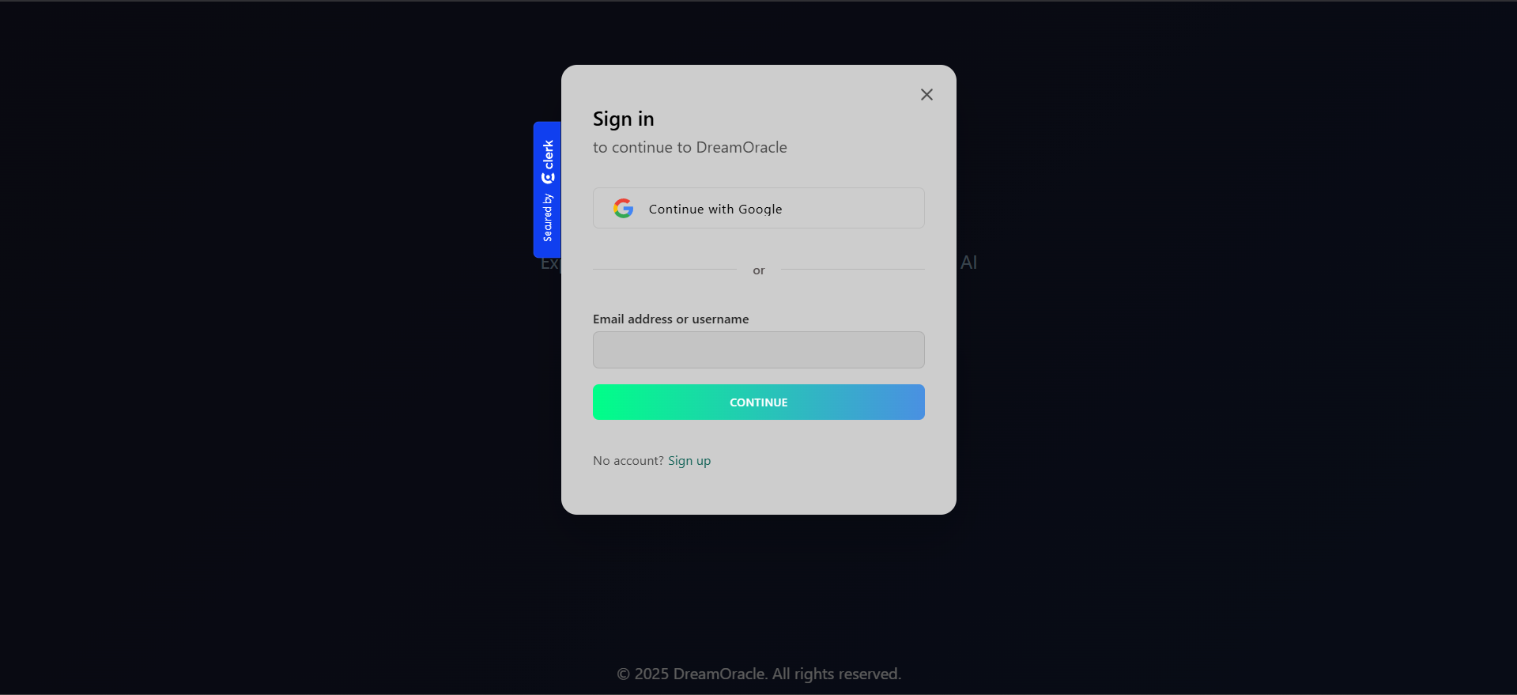

Fig. 4: Login/Sign up page

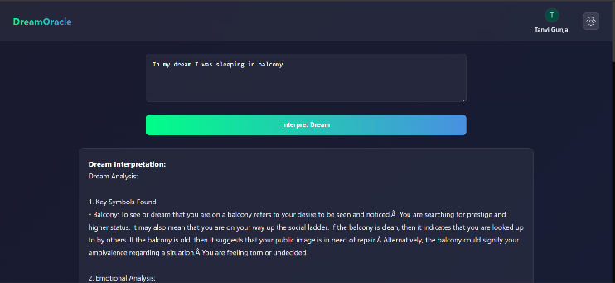

Fig. 5: Frontend Submission Form and Interpretation Display.

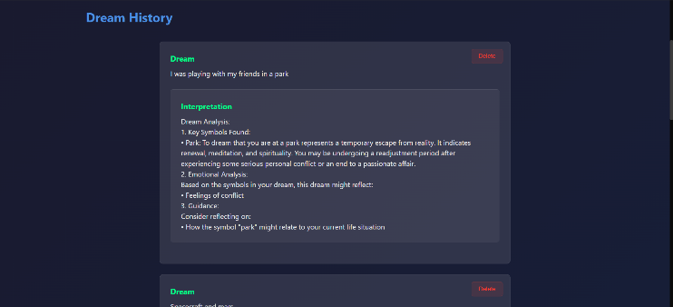

Fig. 6: User History of dreams interpreted

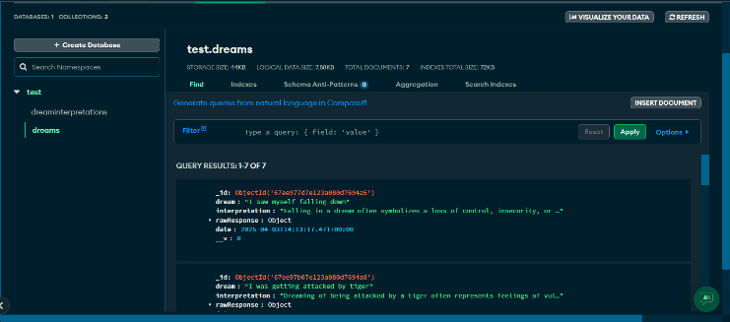

Fig. 7: MongoDB Atlas Dream History Storage Schema.

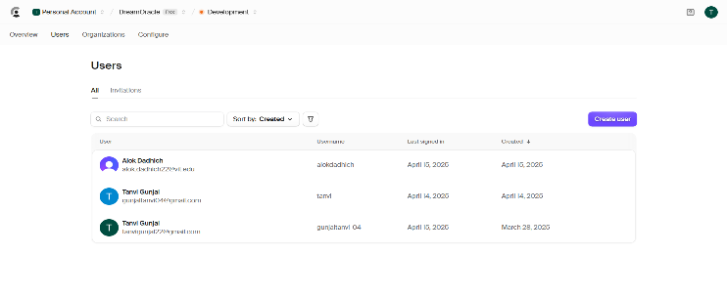

Fig. 8: Clerk Dashboard for User Authentication and Management.

# Discussion

Throughout the development of DreamOracle, several practical challenges were encountered, particularly in the selection of an appropriate AI model for generating symbolic and psychologically relevant dream interpretations.

Initial experiments involved the integration of Vamsi_T5 and ramsrigouthamg/t5_paraphraser, both of which are open-source transformer-based models available on Hugging Face. While these models offered efficient paraphrasing capabilities, they were not trained on datasets rich in symbolic or metaphorical language. As a result, the interpretations produced were overly literal, lacking the psychological nuance and contextual depth required for meaningful dream analysis.

This limitation led to the decision to transition the system’s core interpretation logic to OpenAI’s GPT-based API. The GPT model’s expansive training set and natural language understanding capabilities made it far better suited for the symbolic and abstract nature of dream interpretation. The integration of GPT allowed for more human-like and thematically coherent outputs, aligning better with the emotional and symbolic expectations of users.

However, this shift was not without its own set of trade-offs. The reliance on third-party APIs introduced concerns over latency, recurring costs, and data security. To mitigate this, the backend was designed with caching logic to reduce repeated calls for identical inputs, and the data flow was kept compliant with the authentication layer provided by Clerk, ensuring secure handling of user data.

Additionally, integrating multiple services — including MongoDB Atlas for data persistence, Vercel for frontend deployment, and Clerk for authentication — required careful orchestration to ensure that the system remained modular and scalable. This was addressed by adopting clear separation of concerns in the architecture and implementing Cross-Origin Resource Sharing (CORS) policies to ensure secure and efficient client-server communication.

In conclusion, the development process of DreamOracle reflected a typical modern AI-backed web project cycle: iterative model testing, cloud-native deployment, secure data handling, and user-centric frontend validation. The lessons learned from model selection and system integration reinforced the importance of balancing technical sophistication with user experience — especially in applications designed for self-reflection and personal growth.

# Limitations

Though DreamOracle effectively shows how AI based language models can be practically incorporated into a real-world dream interpretation system, some restrictions were noticed during its construction and rollout:

1. Third Party AI Dependency: Presently, the system uses OpenAI's GPT-based API to produce dream interpretations.
2. User input quality: The interpretive nature of the AI generated output relies greatly on how detailed and clear the user's dream description is.
3. Subjectiveness of Dream Analyzing: Given the fundamentally subjective and symbolic character of dreams, appraising the "accuracy" of the produced interpretation is extremely situational and hard to define.
4. Restricted customization: Though the system keeps personal user history for examination, the AI model itself does not yet include user specific learning.

# Novelty

In academic research as well as in consumer grade applications, DreamOracle stands apart from previous works for its pragmatic, ready approach to symbolical dream analysis.

1. Focus on real world use case.

DreamOracle is meant for normal people and does not need specialized tools; thus, dream analysis is broadly available, unlike systems like DreamNet [4] and EEG based experimental designs working under controlled or clinical conditions.

1. Rejection of Traditional Paraphrasers.

Though several systems use off the shelf language models like Vamsi_T5 and ramsrigouthamg/t5_paraphraser [5][6] to paraphrase user submitted text, DreamOracle uniquely goes beyond this by employing a symbolical, context aware generation technique facilitated interactions with GPT models.

1. Integration of AI with psychological symbolism.

DreamOracle concentrates on producing narrative interpretations based off symbolic language rather than simply organizing or grouping dreams, therefore combining psychological narrative with computational linguistics.

1. Flexible Internet Integration

The system is constructed for scalability and maintainability on the MERN stack, is totally cloud deployed using Vercel and MongoDB Atlas, and runs on the MERN. This makes DreamOracle an instance of artificial intelligent web systems that find a happy balance between backend complexity and user experience.

# Future Scope

Though usable and deployable, the DreamOracle software provides large room for future growth and development:

* Development of a bespoke artificial intelligence model

Future versions of DreamOracle might replace external APIs with language models that have been custom trained using dream specific training sets, carefully adjusted.

* Contextual Customization

User profile-based learning would help DreamOracle remember repeating themes, emotional patterns, and writing styles—which would in turn allow the system to produce more and more personalized interpretations over time.

* Gamification and Engagement

Including interpretation markers, symbolic discovery awards, and guided journaling helps consumers to engage regularly and stimulates more introspection.

* Working together with mental health experts

DreamOracle could become a complementary tool for mental health and therapy if future partnerships with psychologists and mental health professionals help to validate the symbolic interpretations produced by the program.

* Multilinguistic Help

Supporting dream descriptions in many languages would expand reach and let people across the globe explore symbolic dream patterns, hence extending the system's scope.

# Conclusion

DreamOracle shows how artificial intelligence could convert subjective, unorganized human expressions into useful symbolic analysis. The platform provides a interactive and easy tool for consumers looking for personal insight and self-reflection via their dreams thanks to the integration of current web development technologies, cloud services, and sophisticated natural language models.

Although the system encountered difficulties in model selection, API integration, and symbolic depth, iterative improvements—including the change from traditional paraphrasers to GPT powered models—enabled DreamOracle to meet its fundamental goal of providing coherent and psychologically motivated dream interpretations. The work emphasizes the increasing influence of AI on personal development and the need of balancing user experience with technical complexity.

DreamOracle sets the groundwork for next applications fusing cognitive psychology, symbolic reasoning, and artificial intellect driven personal development tools as artificial intelligence grows beyond the present.

##### Acknowledgement

The successful completion of this project would not have been possible without the support and guidance of several individuals and organization. I would like to express my heartfelt gratitude to PRASUNET company, for providing me with the opportunity of being a part this internship program. The practical exposure and mentorship offered during the internship played a significant role in shaping both the technical foundation and the vision of DreamOracle.

##### References

1. Patel, R., et al., "AI-Driven Behavior Prediction from Text", IJCAI, 2021.
2. Jaiswal, N., Sharma, P., "Emotion Recognition in Dream Texts", IEEE Access, 2020.
3. Liu, M., et al., "Subconscious Goal Mapping Using NLP", AAAI, 2022.
4. Gupta, R., "Planning Systems in NLP", AI Review, 2019.
5. Kim, H., et al., "AI-Based Personal Assistants", ACM Computing Surveys, 2021.
6. Smith, J., "AI and Cognitive Dream Analysis", Springer, 2020.
7. Gonzales, F., "Data-Driven Life Goals", Journal of Applied AI, 2022.
8. Arun, R., et al., "Paraphrasing Models for Dream Analysis", ACL Anthology, 2021.
9. Yang, D., et al., "DreamGPT: Generative NLP for Dreams", Nature AI, 2023.
10. Tan, K., et al., "Evaluating NLP APIs", Journal of Software Engineering, 2021.
11. Brown, T., et al., "Language Models are Few-Shot Learners", NeurIPS, 2020.
12. Kaur, G., "Cognitive Linguistics in AI", Linguistics Today, 2022.
13. Zhao, X., "Neuro-symbolic Reasoning in Goal Planning", AI Magazine, 2020.
14. Werner, M., "Human-Centered AI Applications", IEEE Transactions, 2021.
15. Chakraborty, A., "User-Centric NLP Interfaces", ACM IUI, 2022.